Eventbridge
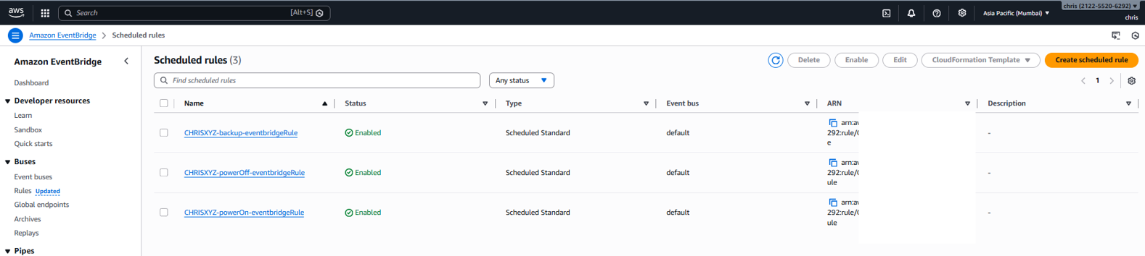
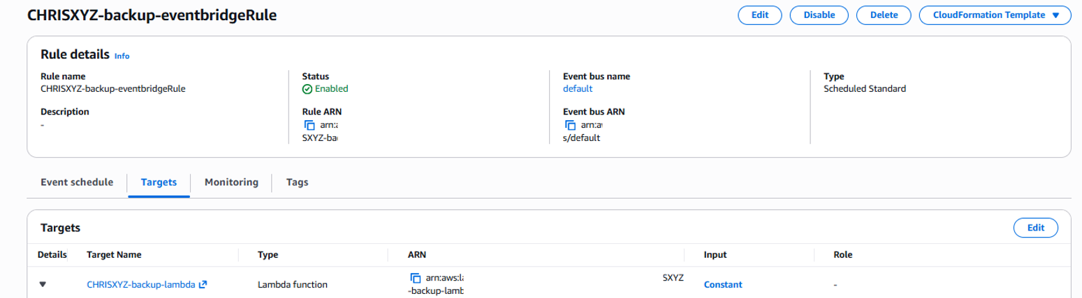
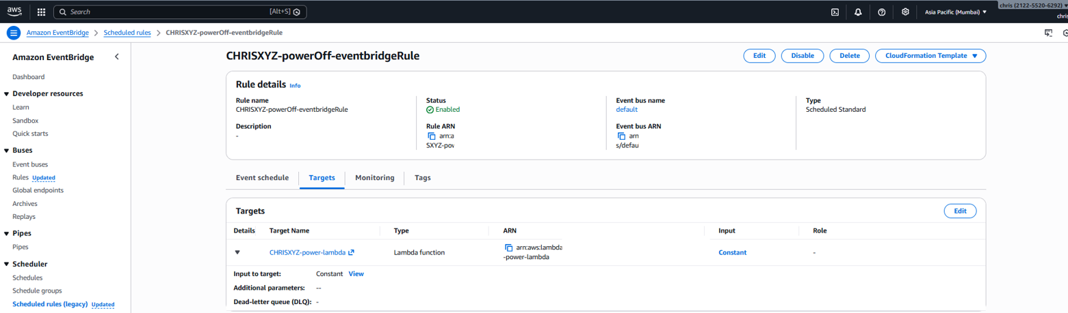
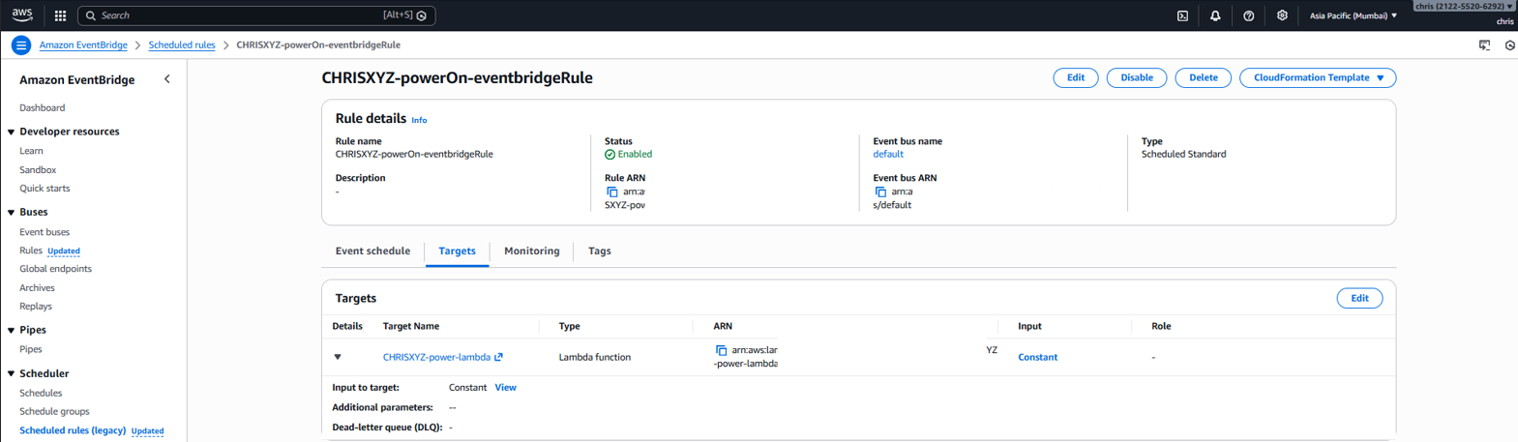

Lambda
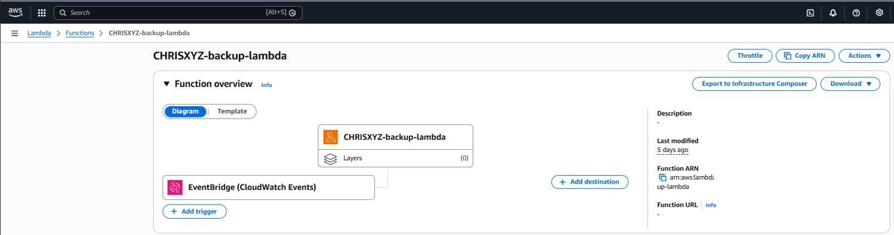
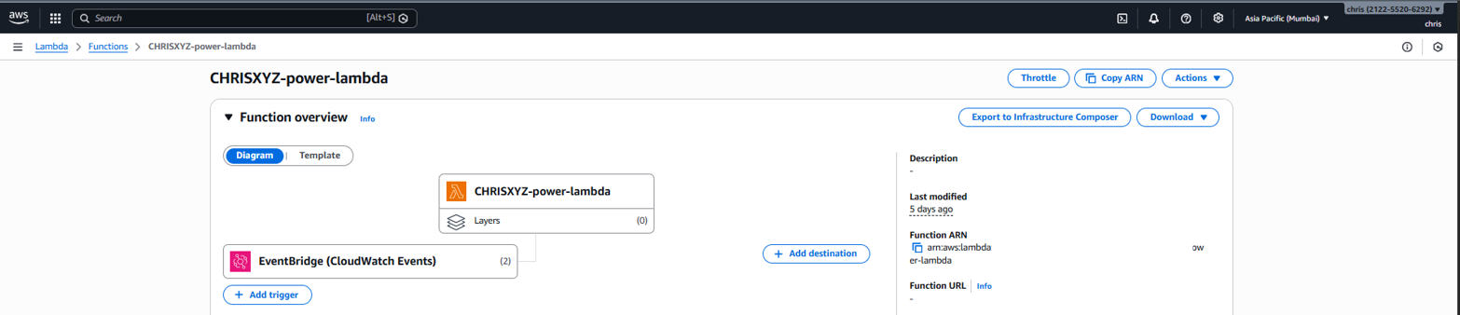

CloudWatch ( history for scheduled lambda runs )
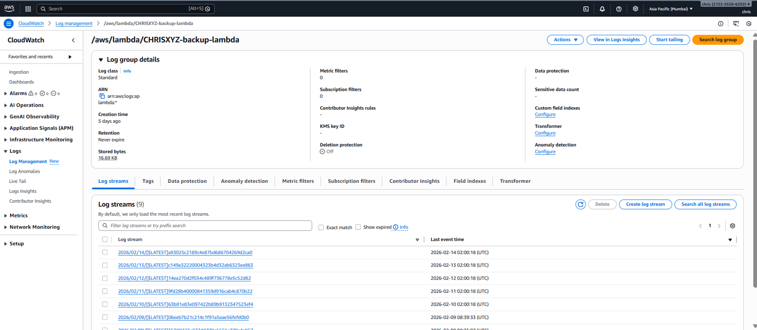
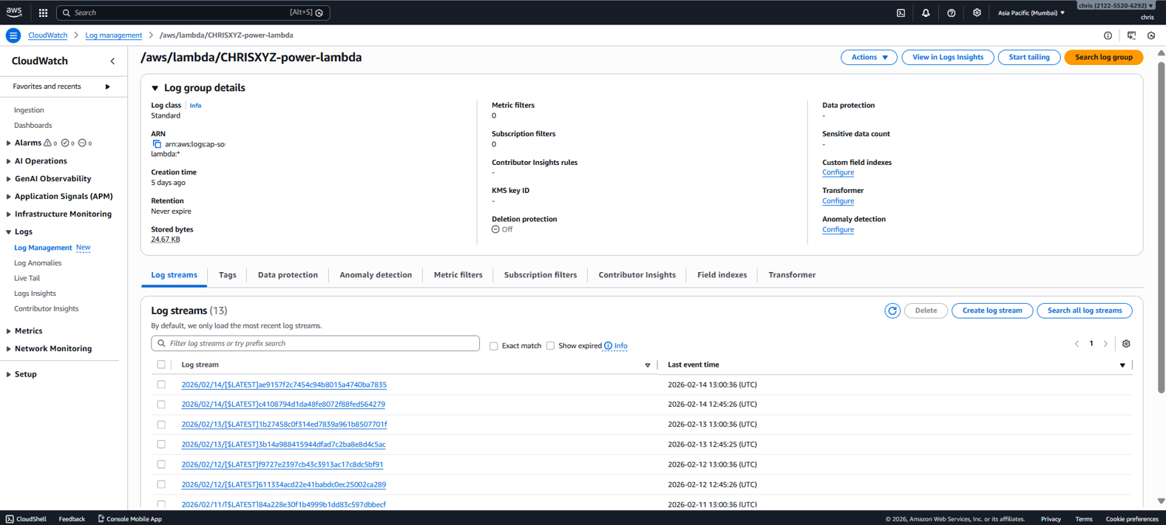
S3 & AMI (backup)
